PAF NOMINATION FORM
Up & Comer Award

NOMINATIONS OPEN: JUNE 15, 2021
NOMINATIONS CLOSE: AUGUST 15, 2021

This form must be completed for all nominees of the PAF Up & Comer Award. The completed form must be return to PAF no later than August 15, 2021.

Purpose
PAF wants to encourage leadership and contributions made among its newest members with the Up & Comer Award. Examples of this leadership and contributions are supporting their PAF Chapter, mentoring paralegal students, volunteering in law-related community and other non-profit programs, and helping those who wish to learn more about the paralegal profession. The award will be presented at the PAF Annual Seminar each year in the fall.

Qualifications (Current PAF Executive Committee members cannot nominate nor are eligible as a recipient of this award)
- Must be a current Active or Student member of PAF
- Must have been a member of PAF for no more than 5 years?

Send your completed Nomination Form either via email to: director@pafinc.org
or via mail to: P.O. Box 11081, Tallahassee, Florida 32302

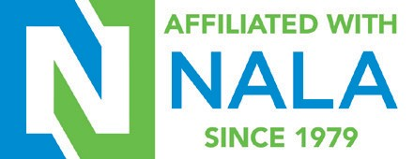

PAF AWARD NOMINATION FORM – Up & Comer

Nominee Information

Name: ________________________________________________________________________

Address: ______________________________________________________________________

Phone: ______________________________ Email: ___________________________________

Nominee Achievements and Contributions
In the box below, describe the most significant achievement or contribution that should be considered for the Up & Comer Award. Include the purpose of the project/program, Nominee’s level of involvement, current status of project/program, and the effect Nominee’s participation on the project/program. If more space is needed, please use an additional sheet.
1. How has this member supported the local Chapter?
2. How has this member supported the chapter members?
3. Does this member volunteer time to the Chapter board or committees?
4. Is this member involved in any other non-profit within the community?

Information of Nominating PAF Member (Nominees must be nominated by a PAF Member)

I hereby nominate _________________________________________ for consideration as a recipient of the PAF Up & Comer Award.

Name: ________________________________________________________________________

Address: ______________________________________________________________________

Phone: ______________________________ Email: ___________________________________

_________________________________________ _____________________________
Signature of Nominating PAF Member Date

Send your completed Nomination Form either via email to: director@pafinc.org
or via mail to: P.O. Box 11081, Tallahassee, Florida 32302

